Chinwendu Imegwu

Managing storage

11/22/2024

1. List Physical Storage Partitions

1. Open a terminal.

2. Use the following commands to list available disks and partitions:

```bash

sudo lsblk

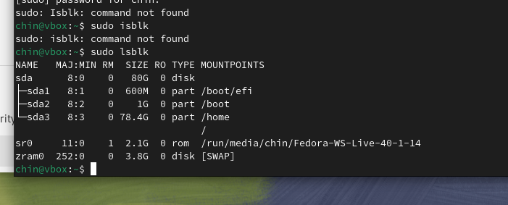

sudo lsblk

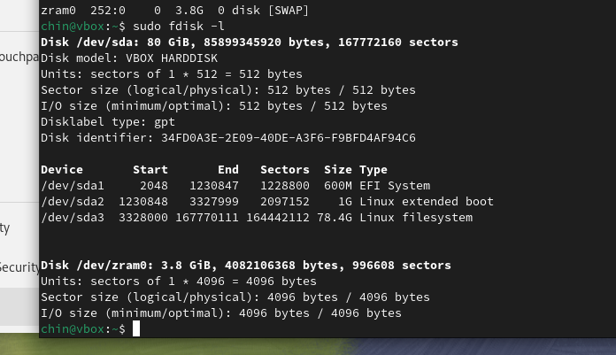

2. Create a Physical Storage Partition

1. Launch `fdisk` to manage partitions:

```bash

sudo fdisk /dev/sdb

```

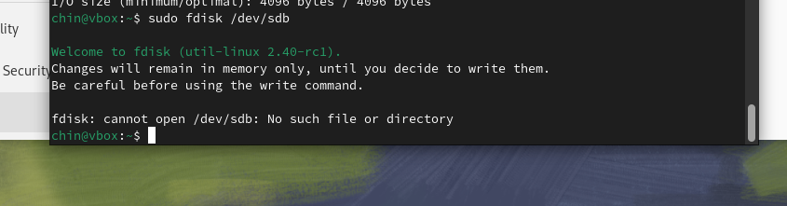

2. Follow these steps inside the `fdisk` menu:

- Press `n` to create a new partition.

- Choose partition type (`p` for primary, `e` for extended).

- Set partition size and press `Enter`.

- Type `w` to write changes and exit.

3. Verify the new partition:

```bash

sudo lsblk

```

---

3. Delete a Physical Storage Partition

1. Open `fdisk` for the disk:

```bash

sudo fdisk /dev/sdb

```

2. Delete the partition:

- Press `d` and select the partition number.

- Type `w` to save changes and exit.

---

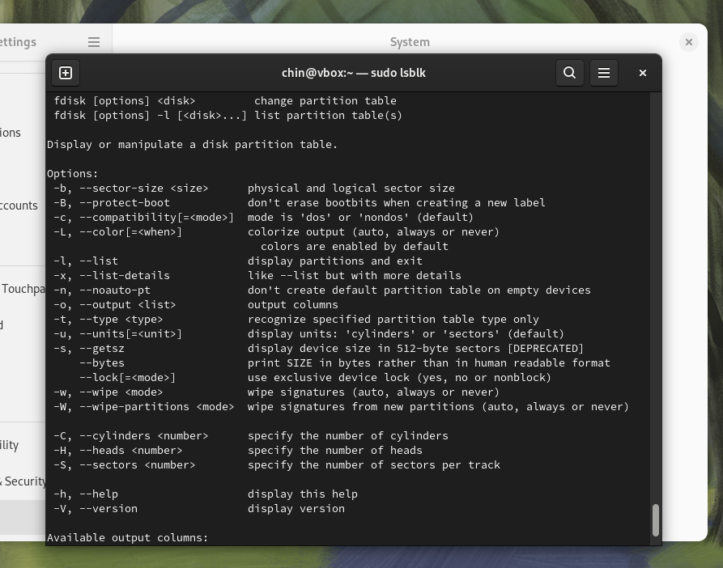

4. Resize the file system if necessary:

```bash

sudo resize2fs /dev/sdb1

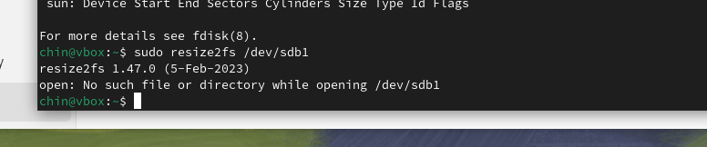

5. Configure and Manage Swap Space

1. Create a swap partition:

```bash

sudo mkswap /dev/sdb2

```

2. Activate the swap partition:

```bash

sudo swapon /dev/sdb2

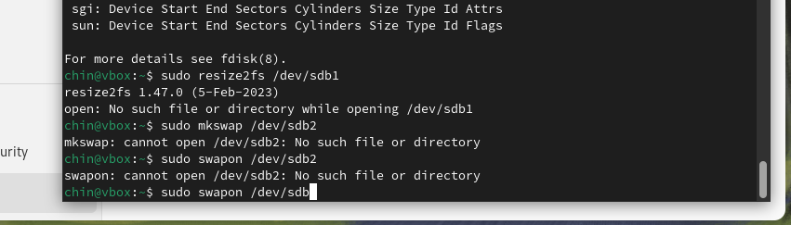

3. Add the swap space to `/etc/fstab`:

```bash

echo '/dev/sdb2 swap swap defaults 0 0' | sudo tee -a /etc/fstab

```

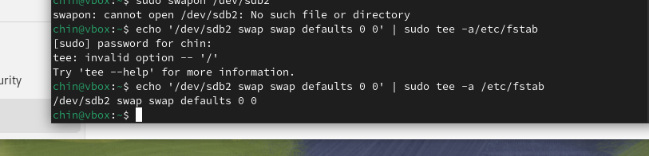

4. Verify swap is active:

```bash

sudo swapon --show

```

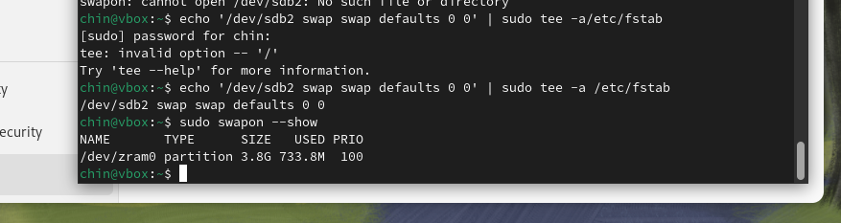

6. Create and Configure File Systems

1. Create a file system on a partition:

```bash

sudo mkfs.ext4 /dev/sdb1

```

2. Mount the file system:

```bash

sudo mkdir /mnt/data

sudo mount /dev/sdb1 /mnt/data

```

3. Add the file system to `/etc/fstab`:

```bash

echo '/dev/sdb1 /mnt/data ext4 defaults 0 0' | sudo tee -a /etc/fstab

```

4. Verify the file system:

```bash

df -h /mnt/data

```

---

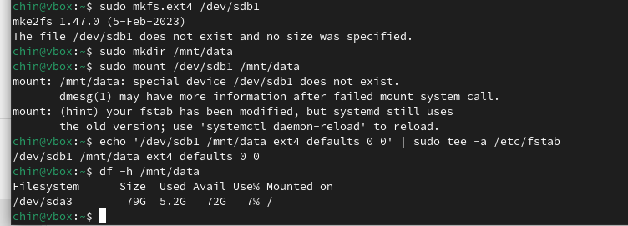

7. Configure Systems to Mount File Systems During Boot

1. Edit `/etc/fstab` and ensure the file system entries are present:

```bash

sudo nano /etc/fstab

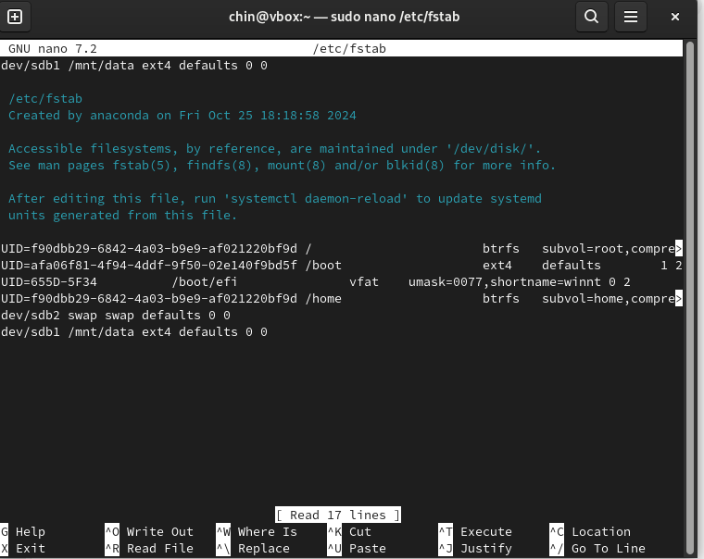

8. Use and Configure Remote File Systems (NFS)

1. Install NFS utilities:

```bash

sudo apt update

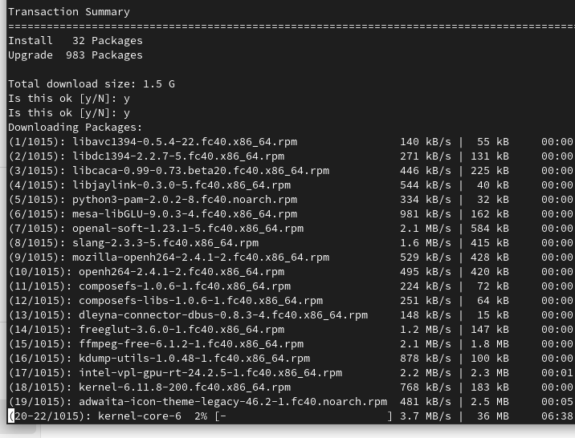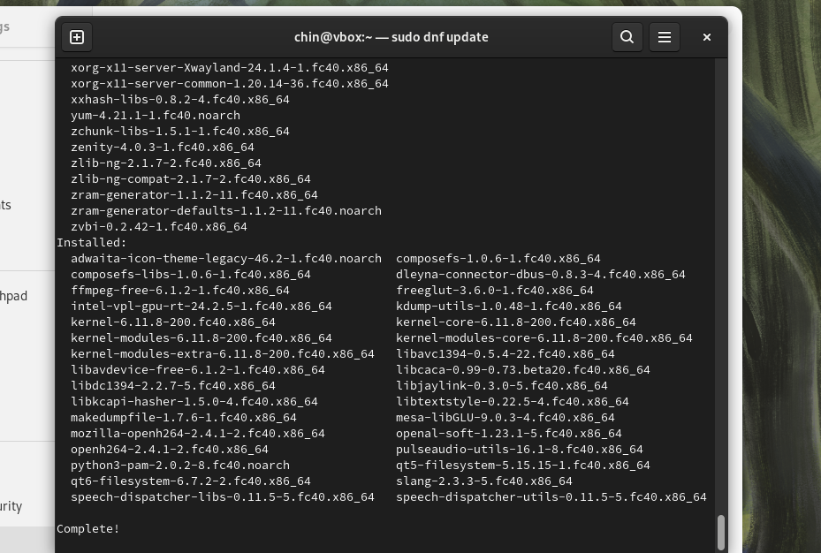

sudo apt install nfs-common nfs-kernel-server

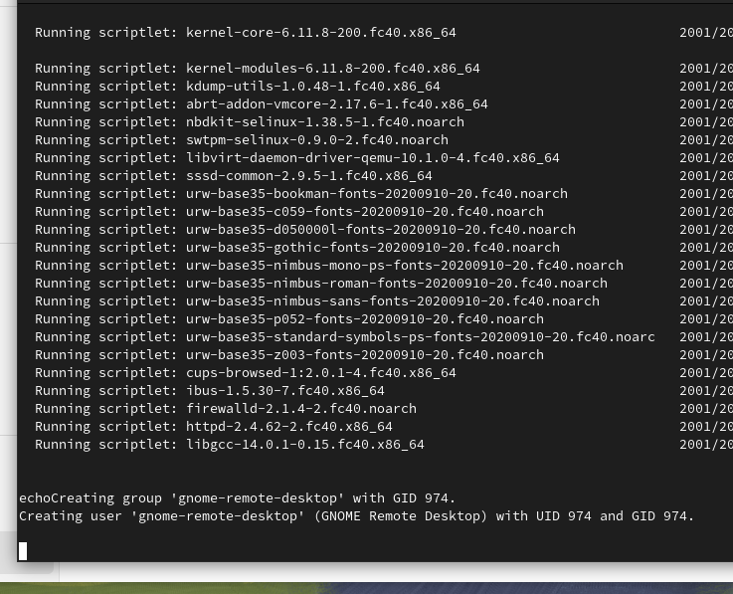

sudo apt install nfs-common nfs-kernel-server

```

2. On the NFS server, export a directory:

- Edit `/etc/exports`:

```bash

echo '/mnt/shared (rw,sync,no_root_squash)' | sudo tee -a /etc/exports

```

- Restart the NFS service:

```bash

sudo systemctl restart nfs-kernel-server

```

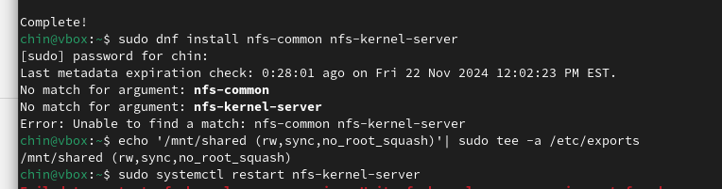

. On the NFS client, mount the remote directory:

```bash

sudo mkdir /mnt/nfs

sudo mount -t nfs <server-ip>:/mnt/shared /mnt/nfs

```

4. Verify the mount:

```bash

df -h /mnt/nfs

```

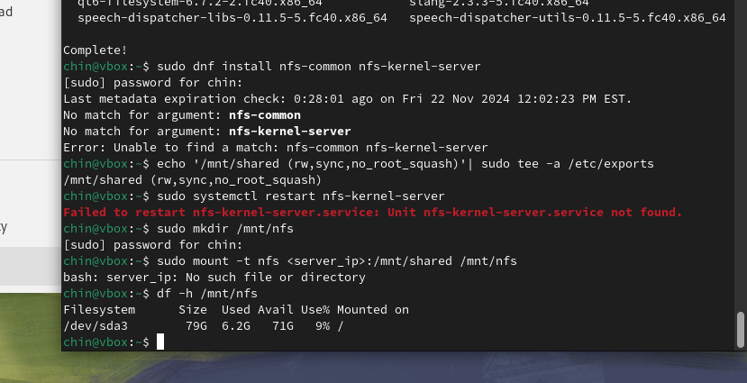

9. Manage Advanced File System Permissions

1. Set permissions using `chmod`:

```bash

sudo chmod 750 /mnt/data

```

2. Change ownership using `chown`:

```bash

sudo chown user:group /mnt/data

```

3. Use Access Control Lists (ACLs) for fine-grained permissions:

- Install ACL tools:

```bash

sudo apt install acl

```

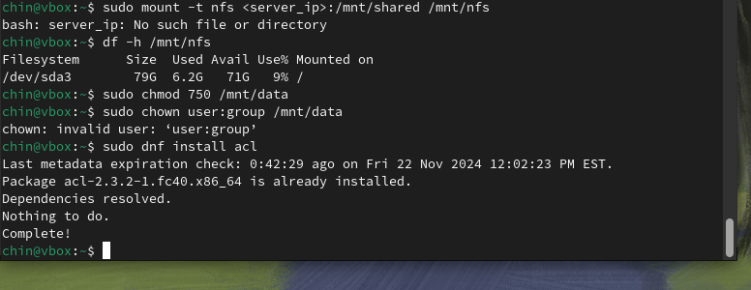

3. Use Access Control Lists (ACLs) for fine-grained permissions:

- Install ACL tools:

```bash

sudo apt install acl

```

- Enable ACL on a file system:

```bash

sudo mount -o remount,acl /mnt/data

```

- Add an ACL for a user:

```bash

sudo setfacl -m u:username:rwx /mnt/data

```

- Verify ACLs:

```bash

sudo getfacl /mnt/data

```

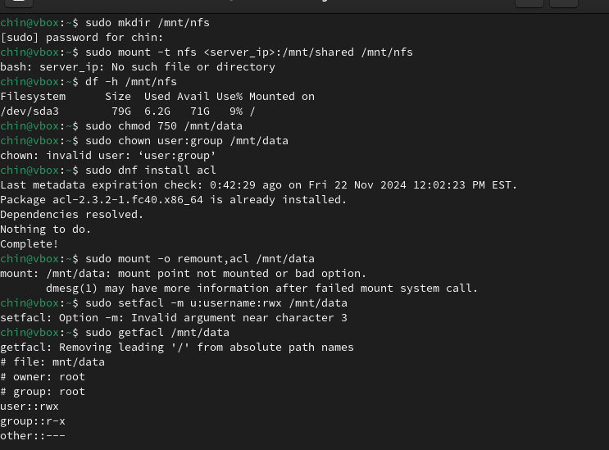

4. Diagnose permission issues:

```bash

ls -l /mnt/data

getfacl /mnt/data

```

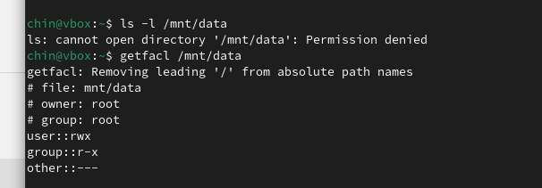

10. Clean Up

1. Unmount file systems:

```bash

sudo umount /mnt/data

```

2. Deactivate swap space:

```bash

sudo swapoff /dev/sdb2

```

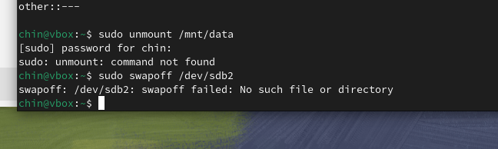

Questions to answer:

1. How can you list all available storage devices and their partitions in Ubuntu?

To list available storage devices and their partitions in Ubuntu, use the lsblk command:

Bash

lsblk

2. What command would you use to create a new partition on a disk, and what steps do you follow within the tool?

To create a new partition, you can use the fdisk or parted tools. Here's an example using fdisk:

1. Open fdisk:  
    Bash  
   sudo fdisk /dev/sda

3. What is swap space, and why is it important for a Linux system?

* Swap space is a virtual memory extension that allows the system to temporarily store inactive memory pages to disk when physical memory is full. This helps prevent system slowdowns or crashes.

4. What are the steps to create, activate, and ensure a swap partition is available at boot?

Create a swap partition: Use fdisk or parted to create a partition and format it as Linux swap.

Activate the swap partition:  
  
 Bash  
sudo swapon /dev/sdaX

Use code with caution.  
  
 Replace /dev/sdaX with the device name of your swap partition.

Make the swap partition persistent: Edit /etc/fstab and add a line like this:  
  
 /dev/sdaX none swap sw 0 0

5. What command is used to format a partition with the `ext4` file system, and how do you verify it was successful?

sudo mkfs.ext4 /dev/sdaX

6. How do you ensure that a file system is automatically mounted during boot, and what file is used for this configuration?

Edit the /etc/fstab file to define the mount point, file system type, mount options, dump frequency, and pass number. For example:

/dev/sda1 /mnt/data ext4 defaults 0 2

7. What are the roles of the NFS server and client, and what are the key steps to configure each?

* Install the NFS server package: sudo apt install nfs-kernel-server

Configure the exported directories in /etc/exports:  
 /export/share *(rw,sync,no_root_squash)

* Start the NFS server: sudo systemctl restart nfs-kernel-server

NFS Client:

* Install the NFS client package: sudo apt install nfs-common
* Create a mount point: sudo mkdir /mnt/nfs

8. What command would you use on the client to mount an NFS share, and how can you make the mount persistent?

To mount the NFS share:

Bash

sudo mount server_ip:/export/share /mnt/nfs

Use code with caution.

To make the mount persistent, add a line to /etc/fstab:

server_ip:/export/share /mnt/nfs nfs defaults 0 0

9. How can Access Control Lists (ACLs) be used to provide more granular file and directory permissions compared to `chmod` and `chown`?

ACLs provide more flexible permission control than traditional chmod and chown. Use the setfacl command to set ACLs on files and directories.

10. If a user reports they cannot access a directory despite being granted permissions, what commands can you use to diagnose the issue?

Check file permissions:  
 Bash  
ls -l /path/to/directory

Use code with caution.

Check effective user and group IDs:  
 Bash  
id

Use code with caution.

Check SELinux permissions:  
 Bash  
audit2allow -a -p z -S access_pt -o user_home_t -F type=nfs_file

Use code with caution.

Check NFS server logs: Look for error messages related to access denied or network issues.